

**The Company**

Cyteir Therapeutics is a leader in the discovery and development of novel therapeutics based on the biology of DNA repair and synthetic lethality for the treatment of cancer and autoimmune diseases. Our initial approach takes advantage of DNA damage overload to induce selective self-destruction of cells by targeting the DNA repair activity of RAD51.

**Therapeutic Approach: Gain-of-Function Synthetic Lethality**

Genomic instability is caused by an imbalance between DNA damage and DNA repair, and is a key driver of many disease processes. It represents a crucial vulnerability in cancer and in the cells that cause many autoimmune diseases.

Normal cells have very little DNA damage and have sufficient repair capacity to handle it. Diseased cells suffer an excess of DNA damage and thus are sensitive to small perturbations in their DNA-repair capacity. By precisely targeting DNA repair, the diseased cell is overwhelmed by its own DNA damage and undergoes cell death – a therapeutic effect known as “synthetic lethality”.

Precision targeting of DNA repair proteins in biomarker-defined diseases promises to deliver potent and highly selective therapeutic effects and potentially resulting in fewer side effects than traditional chemotherapy while maintaining integrity of healthy cells in the process.

**A novel screening approach for DNA-repair drug discovery**

Cyteir has developed a unique screening system designed to rapidly identify novel DNA repair inhibitors that function with exceptional selectivity against biomarker-defined diseased tissues. This screening system utilizes primary cells derived from tissues of interest rather than traditional cell lines. Genetic constraints are engineered into the cells, which enhances the power to detect hits on the desired pathway. The power of this integrated platform is the robust ability to customize it for tissues or diseases of interest, to rapidly sort out the “true hits” from the false positives and negatives, and to dramatically reduce the number of “poor hits” that lead to failure at later stages.

**Small molecules that selectively target RAD51 in cells defined by AID gain-of function**

Cyteir’s small molecule therapeutics are selective for disease-causing cells associated with activation-induced cytidine deaminase (AID), a DNA-damaging enzyme normally present in a very small fraction of healthy immune cells. AID is ‘hyperactivated’ in many cancers and autoimmune diseases. In cancer, AID causes widespread mutations, accelerating tumor progression and therapy resistance. In autoimmune diseases, AID hyperactivation results in the production of high-affinity autoantibodies, but also causes cellular stress. DNA repair via the protein RAD51 protects diseased cells and tissues from death by AID-generated DNA damage. Cyteir has developed a unique approach to targeting RAD51. Unlike conventional therapeutic approaches that block enzymatic activities, our strategy is designed to

reduce RAD51 activity in diseased cells by specifically reducing its concentration in the nucleus, thereby limiting the degree to which it can repair DNA damage, while preserving its baseline function in normal cells. Our lead development candidate drug is undergoing IND enabling studies now.

**MANAGEMENT TEAM**

**Markus Renschler, M.D.**

President & CEO

**Kevin Mills, Ph.D.**

Chief Scientific Officer

**Chris Thomajan**

Chief Financial Officer

**Jean-Marc Lapierre, Ph.D.**

VP, Chemistry

**Darryl Patrick, D.V.M.**

Head, Preclinical Development

**BOARD OF DIRECTORS**

**Racquel Bracken**

VP, Venrock

**Jean George**

General Partner, Lightstone

**Markus Renschler, M.D.**

President and CEO, Cyteir

**Timothy Romberger**

Co-Founder, Cyteir

Managing Director, TRC Advisory

**Bart Van Hooland**

Managing Partner, DROIA

**Joe Zakrzewski**

Independent Investor

**Founded: June 2012**

**Financing:**

**Series A:** $5.5M (Nov. 2015)

**Series B:** $35M (Mar. 2018)

**Contact:**

Markus Renschler, M.D.

Cyteir Therapeutics

763E Concord Ave

Cambridge, MA 02138

info@cyteir.com

(857) 285-4140 www.cyteir.com

For career inquiries:

careers@cyteir.com

**PROGRAMS**

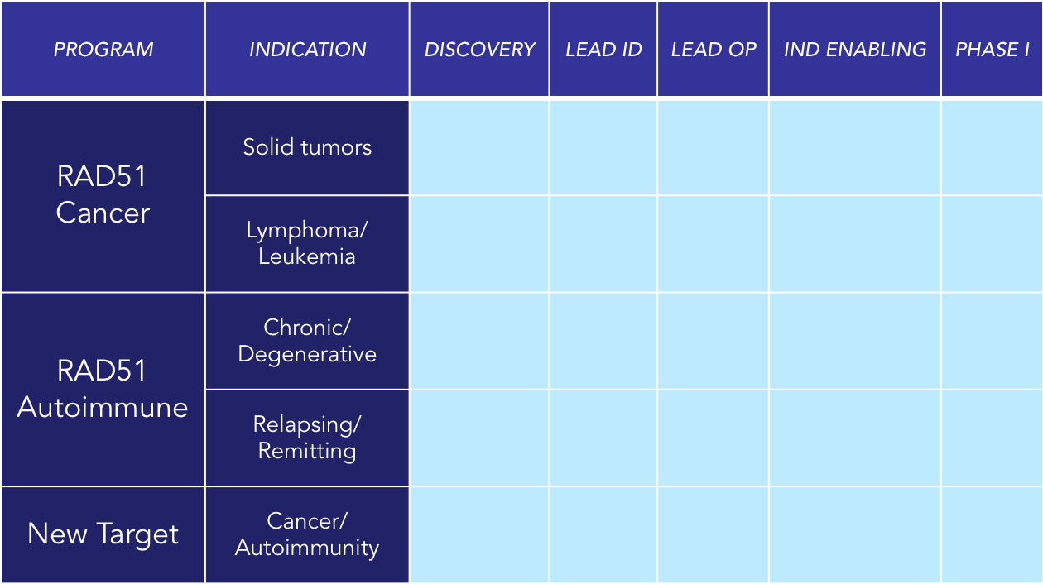

**AID / RAD51 Axis**

**Key Publications**

1. Hasham, MG, et al. Widespread genomic breaks generated by activation-induced cytidine deaminase are prevented by homologous recombination. *Nat Immunol*. 2010 Sep;11(9):820-6.
2. Lamont, KR, et al. Attenuating homologous recombination stimulates an AID-induced antileukemic effect. *J Exp Med*. 2013 May;210(5):1021-33.
3. Ward, A, et al. Targeting homologous recombination, new pre-clinical and clinical therapeutic combinations inhibiting RAD51. *Cancer Treat Rev*. 2015 Jan;41(1):35-45.
4. Ratiu JJ, Racine JJ, Hasham MG, Wang, Q, Branca J, Chapman HD, Zhu J, Donghia N, Philip V, Schott WH, Wasserfall C, Atkinson MA, Mills KD, Leeth CM, Serreze DV. Genetic and Small Molecule Disruption of the AID/RAD51 Axis Similarly Protects Nonobese Diabetic Mice from Type 1 Diabetes through Expansion of Regulatory B Lymphocytes. (2017) Journal of Immunology. 2017; 198(11): 4255-4267.

